

Project

Submitted To Sir Usman Ghani

Submitted By Safwan Rao

Roll No S23BDOCS1M01225

Subject Data structure & Algorithm

Department Computer Science

**Description:**

The Phone Directory application is designed to provide a user-friendly interface for

managing contacts. It utilizes an unordered_map data structure to efficiently store and

retrieve contact information based on unique keys. This project report provides a

comprehensive overview of the application, including its functionality, data structure,

and implementation details.

Main Functionalities of Program are:

* Add Contact
* Search Contact
* Display Contacts

I have use Structure to store multiple data from input. I have name struct as

phoneBook & then created class PhoneDirectory.

**Working**

**Adding Contacts to directory:**

This Function create a new contact by taking Name [FULL], Phone Numbers. Then store them in Linked List [Circular] which is used as data structures. For this user have to select 1 from directory. Email is optional but remaining are mandatory.

• Example & Output:

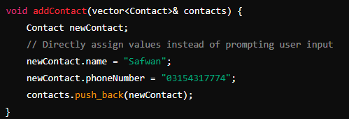

**Searching for a Contact by Name**

This Function is built for user to search the contact:

• Searching by Name:

In this, user will enter either Fullname or FirstName or LastName.. From here two conditions arise:

1. If user have enter FullName, then algo will print contacts with that Fullname.

2. If user either enter firstname or lastname, algo will print all the contacts from directory that have that name in it, even if the user’s input is other’s contact is middle name.



**Display Contacts:**

This Function is built for user to Display all contacts, present in the directory. For this

user have to select 2 from directory. It will print all the contacts with in the directory.

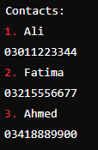

As I saved only 3 numbrs so that’s why here showing only 3 but itv depend on your phonebook how many number they contains show hre